Forecast

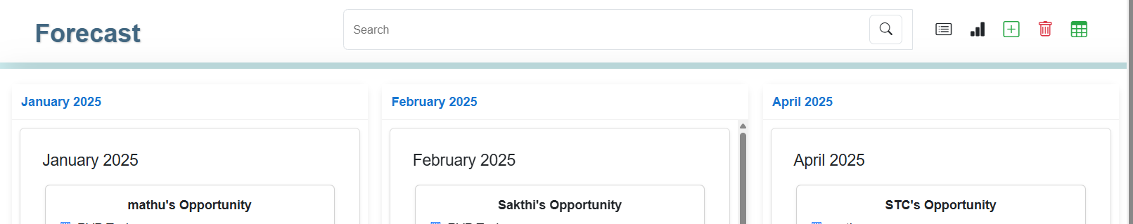

Change Search contact
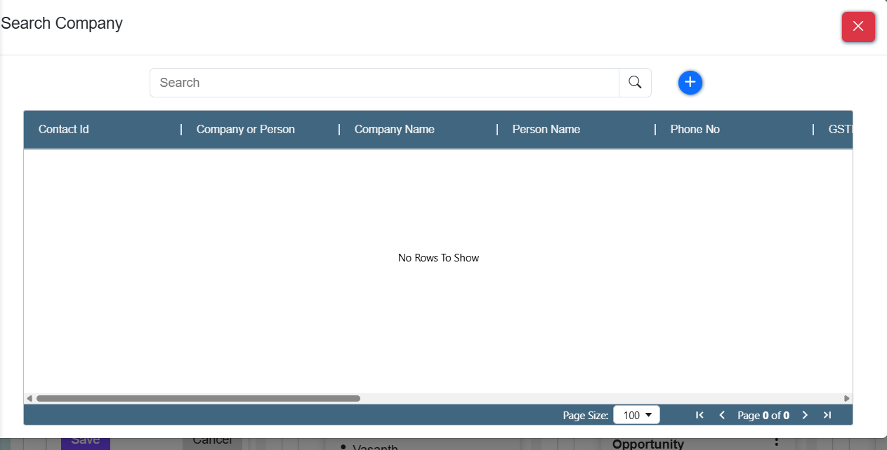

3.To hide the red marked button
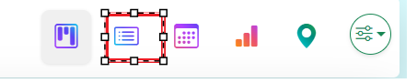
4..not clearly visibility to move down after monthly payment
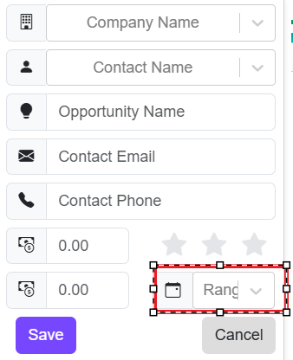

5. calendar meeting event details to add “Time”
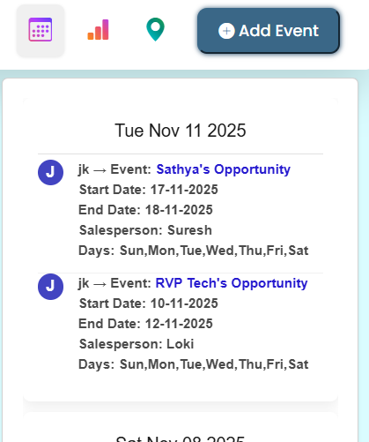

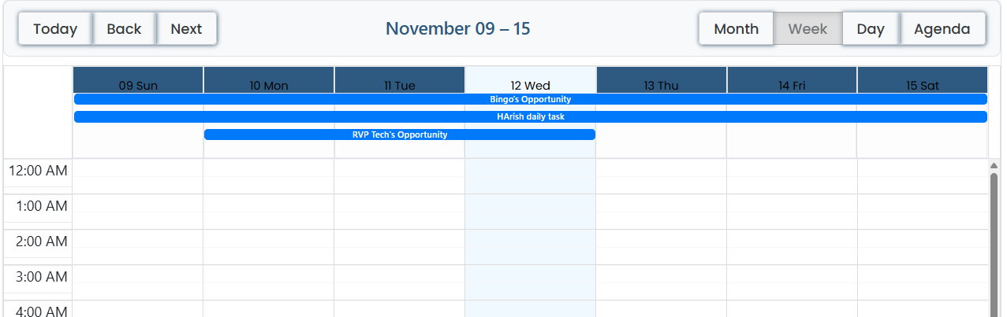
6.To add the “search option symbel”
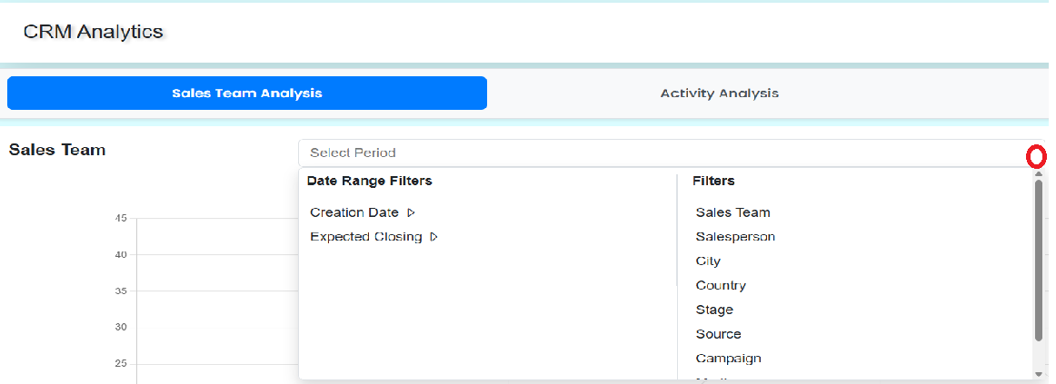
7.”Delete “ not working
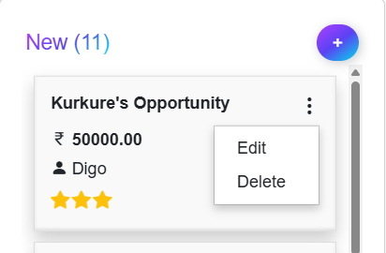
8.Reduce the combo list height (to load minimum data)
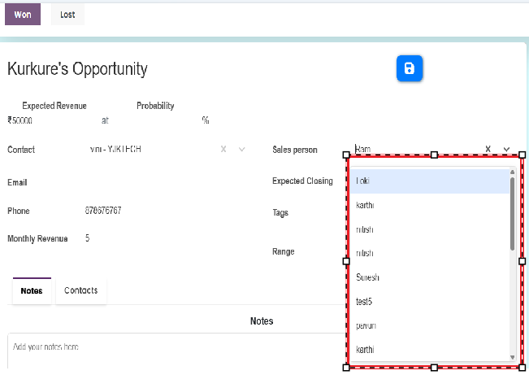

9.To move the contold to above (to add the
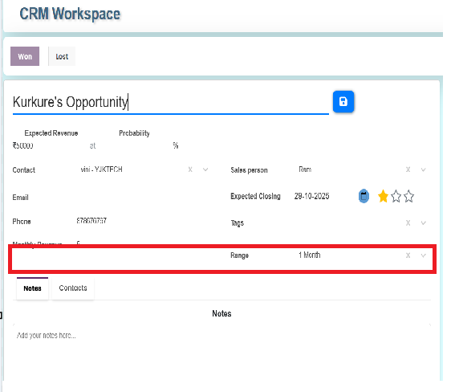

10.I have edit the “activity” for date but not showing heading
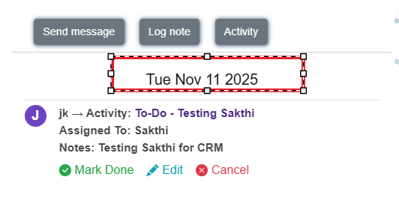
11. I have click the “meeting Event” then show the meeting details .(to change the + option )
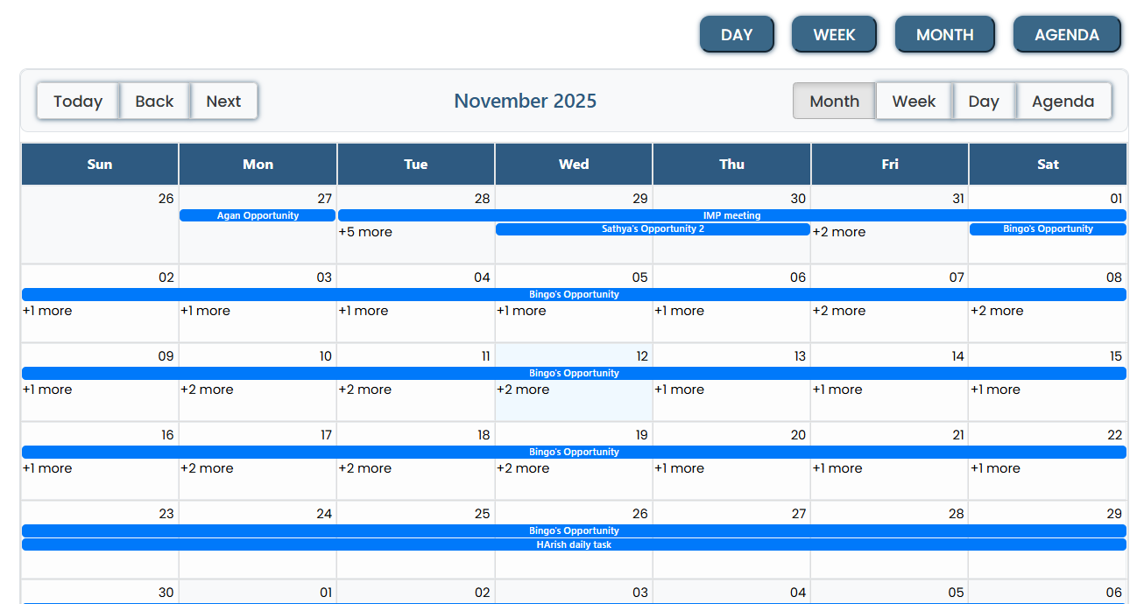

12.Group by not working .not working “lose” options
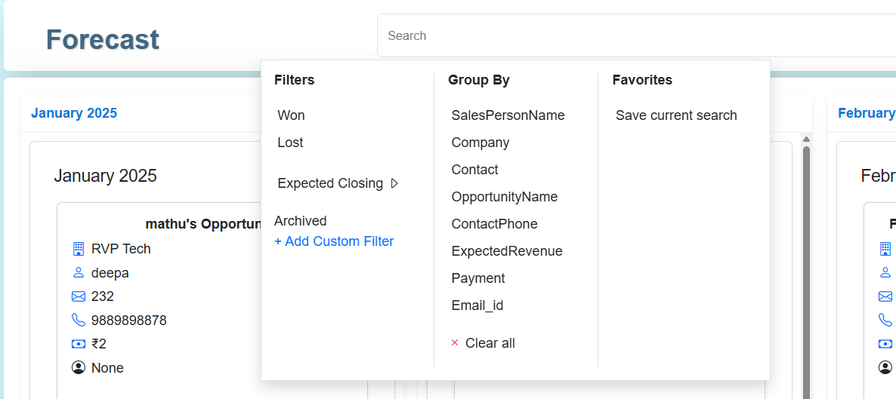
13.Forecast
Horizondal scroll bar and vertical scroll bar fix properly
